UNIT 9 SPEAKING
- Complete the sentences with your own ideas.
- Before the class started, I...
- I enjoy learning English, although...
- I'm going to keep learning English until .....
- After we finished the last English class, I..
- As soon as this is class is over, I...
- My phone rang just as I ...
- When I went shopping recently, I ...
- I first met my best friend while I ...

- Look at the book covers. Which books do you think are children’s literature?
Which are young adult literature? What’s the difference? Can you think of more examples?
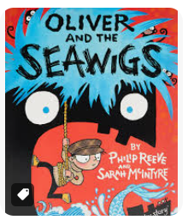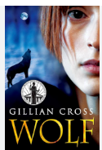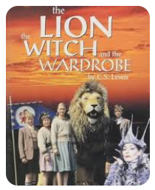
- Should young adult novels show all the real problems that teenagers have in their personal lives? Why/Why not?
- Should children's stories teach them to behave well?
- Should they always have happy endings? Why/Why not?
- Did any book have a big effect on you when you were young? What was it? How did it affect you?
- When do people feel …?
angry
nervous
delighted
- stressed
- disappointed
- upset
- homesick
- jealous
- proud
- scared
- amazed
- lonely

